1. Review from p.41 to p.50 in the text book.

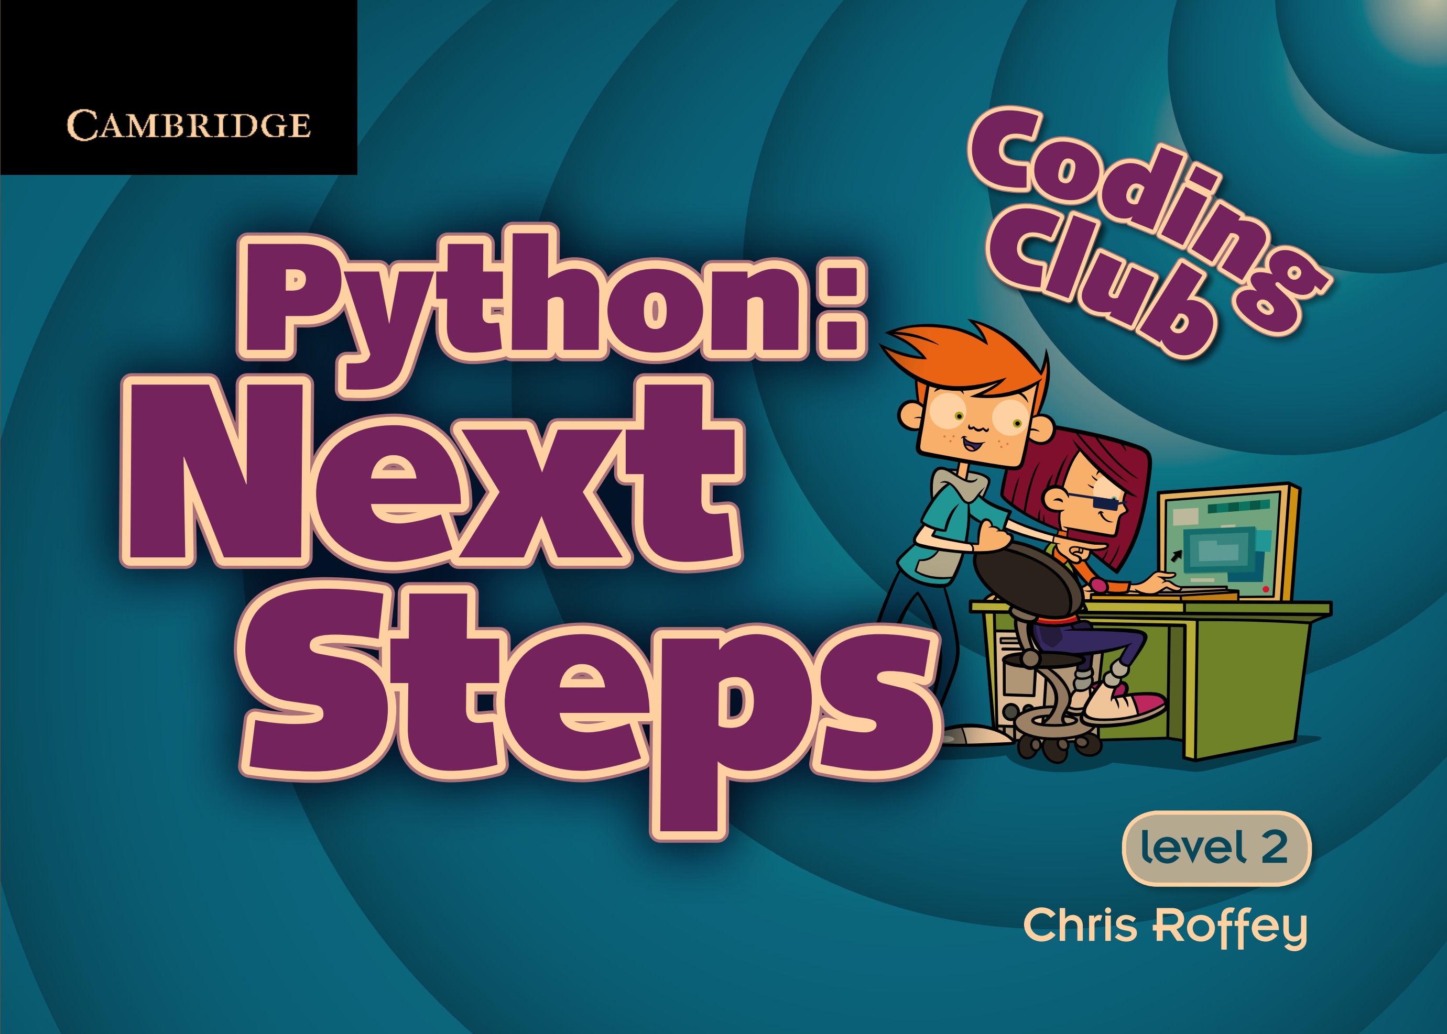

1. Summarize the concepts you think are important among those contents.